Directions: Define the domain of the following functions.

$f(x)=\sqrt{x−4}$ D: $[4,∞)$ $f(x)=x^{2}−\text{12}x+\text{32}$ D: R

$f(x)=\frac{x+8}{4x^{2}−\text{36}}$ D: R except $x=3,−3$ $f(x)=\frac{5x}{2x^{3}−4x^{2}}$ D: R except $x=2,0$

$f(x)=\sqrt{\text{64}−x^{2}}$ D: $[−8,8]$

Directions: Use interval notation to define the domain and range of the following graphs.
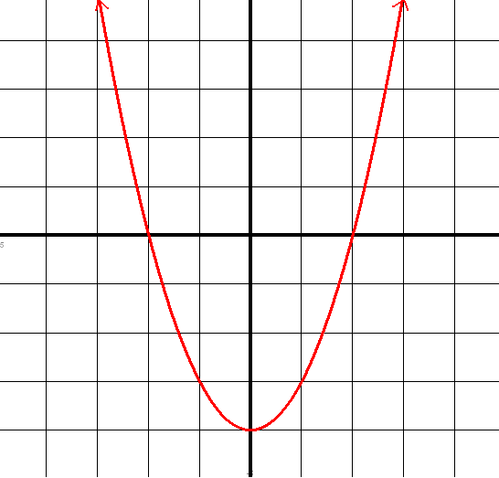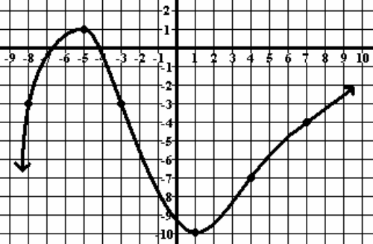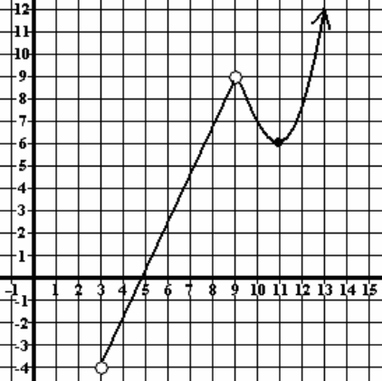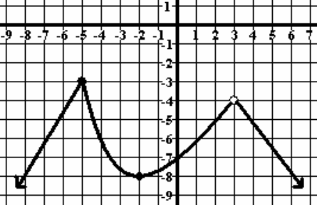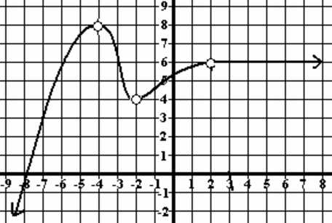

D: $(−∞,∞)$ D: $(−∞,∞)$ D: $(3,9)(9,∞)$ D: $(−∞,3)(3,∞)$ D: $(−∞,−4)(−4,−2)(−2,2)(2,∞)$
R: $[−4,∞)$ R: $(−∞,∞)$ R: $(−4,∞)$ R: $(−∞,−3]$ R: $(−∞,8)$

